PIZZA SALES SQL QUERIES
CREATE DATABASE IF NOT EXISTS pizza_sales_db;
USE pizza_sales_db;

DROP TABLE pizza_sales_raw;
CREATE TABLE pizza_sales_raw (
pizza_id INT,
order_id INT,
pizza_name_id VARCHAR(100),
quantity INT,
order_date VARCHAR(20),
order_time VARCHAR(20),
unit_price DECIMAL(10,2),
total_price DECIMAL(10,2),
pizza_size VARCHAR(10),
pizza_category VARCHAR(50),
pizza_ingredients TEXT,
pizza_name VARCHAR(100)
);
Data Cleaning Part:
ALTER TABLE pizza_sales_raw
ADD COLUMN new_order_date DATE;

SET SQL_SAFE_UPDATES = 0;

UPDATE pizza_sales_raw
SET new_order_date =
CASE
WHEN order_date LIKE '%/%'
THEN STR_TO_DATE(order_date, '%d/%m/%Y')

WHEN order_date LIKE '%-%'
THEN STR_TO_DATE(order_date, '%d-%m-%Y')
END;
SET SQL_SAFE_UPDATES = 1;

A. KPI’s
1. Total Revenue:
SELECT SUM(total_price) as Total_Revenue from pizza_sales_raw;
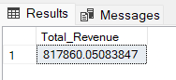
2. Average Order Value
SELECT SUM(total_price)/COUNT(distinct(order_id)) as Average_Order_Value from pizza_sales_raw;
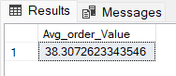
3. Total Pizzas Sold
SELECT SUM(quantity) as Total_pizzas_sold from pizza_sales_raw;
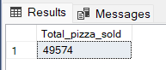
4. Total Orders
SELECT COUNT(DISTINCT (order_id)) as total_orders FROM pizza_sales_raw;
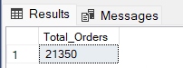
5. Average Pizzas Per Order
SELECT
ROUND(SUM(quantity)/COUNT(DISTINCT order_id),2) as avg_pizza_per_order
FROM pizza_sales_raw;
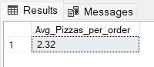
B. Daily Trend for Total Orders
SELECT DAYNAME(new_order_date) AS day_name,
COUNT(DISTINCT order_id) AS total_orders
FROM pizza_sales_raw
GROUP BY DAYNAME(new_order_date);
Output:
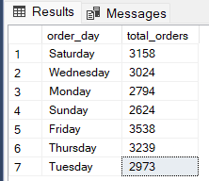
C. Hourly Trend for Orders
SELECT HOUR(order_time) AS order_hour,
COUNT(DISTINCT order_id) AS total_orders
FROM pizza_sales_raw
GROUP BY HOUR(order_time)
ORDER BY order_hour;

Output
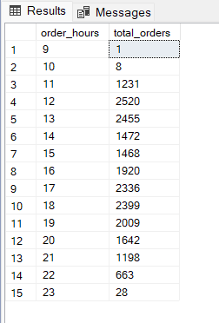
D. % of Sales by Pizza Category
SELECT pizza_category,
CAST(SUM(total_price) as DECIMAL(10,2)) AS total_revenue,
ROUND(SUM(total_price)*100/(SELECT SUM(total_price) FROM pizza_sales_raw),2) AS PCT
FROM pizza_sales_raw
GROUP BY pizza_category;
Output
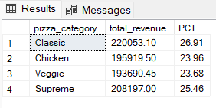
E. % of Sales by Pizza Size
SELECT pizza_size,
ROUND(SUM(total_price),2) as total_revenue,
ROUND(SUM(total_price)*100/(SELECT SUM(total_price) FROM pizza_sales_raw),2) as PCT
FROM pizza_sales_raw
GROUP BY pizza_size
ORDER BY PCT DESC;
Output
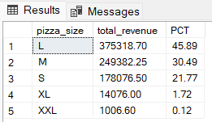

F. Total Pizzas Sold by Pizza Category
SELECT pizza_category, SUM(quantity) as Total_Quantity_Sold
FROM pizza_sales
WHERE MONTH(order_date) = 2
GROUP BY pizza_category
ORDER BY Total_Quantity_Sold DESC
Output
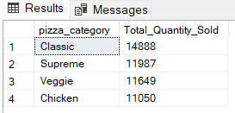
G. Top 5 Best Sellers by Total Pizzas Sold
SELECT pizza_name, sum(quantity) AS Total_Pizza_Sold
FROM pizza_sales_raw
GROUP BY pizza_name
ORDER BY Total_Pizza_Sold DESC
LIMIT 5;
Output
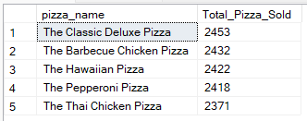

H. Bottom 5 Best Sellers by Total Pizzas Sold
SELECT pizza_name, SUM(quantity) as Total_Pizza_Sold
FROM pizza_sales_raw
GROUP BY pizza_name
ORDER BY Total_Pizza_Sold DESC
LIMIT 5;
Output
